*inkom*

15 mei

20 juni

2021

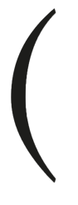

**De locatienaam**

De titel kan ook onderaan.

adia at earum eliquo tem. Ehendam quas et untotate vitemporro bere nulpa culloresto modia que ius, sent re a dollaccus ipis et incius dolla qui omnis pro eiur, omniendus.Hil est, quatem nis senimus et ut pore, quia

**www.vermeylenfonds.be**

**€15**